Failure analysis study of a tower crane collapse due to height increasing
Análise do colapso de uma grua torre devido ao incremento da altura

Francisco Castro¹ | Nuno Viriato Ramos¹ | Francisco Queirós de Melo¹ | Pedro Moreira¹ | Mário Vaz^{2,1}
¹INEGI – Instituto de Ciência e Inovação em Engenharia Mecânica e Engenharia Industrial, Portugal
²FEUP – Faculdade de Engenharia da Universidade do Porto (FEUP), Portugal, gmavaz@fe.up.pt

Abstract
The failure of a large tower crane can cause high economic losses and serious injuries or fatalities, that’s why it’s extremely important to identify, not only the causes of its collapse for the attribution of responsibilities, but also and specially focusing on the prevention of new disasters. This paper aims to study and investigate the main causes of the accident and its reconstruction by sequenced collapse stages. Static and dynamic computational simulations were performed to understand the main changes of the structure dynamic behavior due to the height increasing and eventual material changes, which was not contemplated in the manual. It was possible to conclude that the main cause for the accident was due to the excitation of natural frequencies of the structure associated to a pendulum effect of the suspended loads. The changes in the flexibility of the structure due to the increase in height and its dynamic interaction with the oscillations of the suspended load are presented and discussed.
Keywords: Experimental mechanics, Computational Simulations, Tower Crane Collapse, Forensic Engineering

Resumo
A queda de uma grua torre de grande porte pode causar elevados prejuízos económicos e ferimentos graves ou mortais, por isso é extremamente importante identificar não só as causas do seu colapso para a atribuição de responsabilidades, mas também e especialmente contribuir para a prevenção de novos desastres. Este trabalho tem como objetivo estudar e investigar as principais causas do acidente e realizar a sua reconstrução por etapas sequenciadas até ao colapso. Simulações computacionais estáticas e dinâmicas foram realizadas de modo a estudar as principais alterações no comportamento dinâmico da estrutura devido ao aumento de altura e eventuais alterações de material, que não estejam contemplados no manual. Foi possível concluir que a principal causa do acidente foi a excitação das frequências naturais da estrutura associada a um efeito pêndulo de cargas suspensas. São apresentadas e discutidas as alterações na flexibilidade da estrutura devido ao aumento da altura e a sua interação dinâmica com as oscilações da carga suspensa.
Palavras-chave: Mecânica experimental, Simulações Numéricas, Colapso de Grua Torre, Engenharia Forense

1- Introduction

A tower crane is a rotatable cantilever jib on the top of a steelwork tower mounted on a construction site, which its main function is moving loads at height. Tower cranes play a critical role in the construction industry, enabling the efficient lifting and transportation of heavy materials at large heights. Due to the level they can be mounted and their unique operating conditions, they are subject to several forces, with and without moving loads and exposed to adverse weather conditions.

2- the accident

2.1. Tower crane
The crane involved in this accident is a ???-??? and according to the data provided by the manufacturer, this is a fixed tower crane characterized by an available maximum height of ?? meters and a maximum boom length of ?? meters.
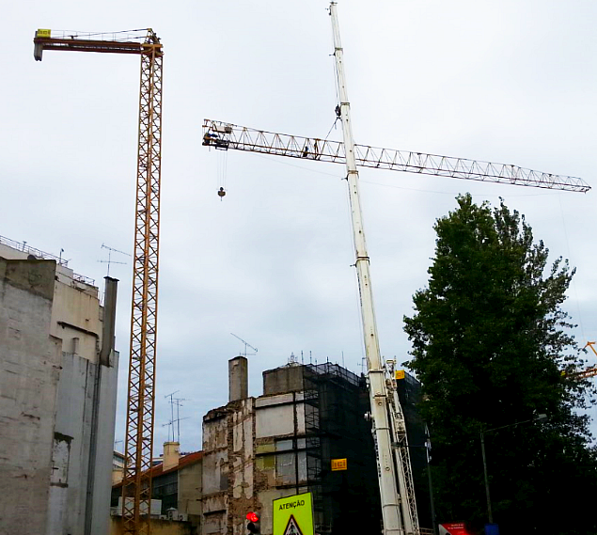
Fig. 1 | Tower crane being assembled.

5- Conclusions
The tower crane collapse presented in this paper was not caused by a single factor; rather it was due to a combination of circumstances that significantly increased the risk of collapse.
Finally, it is recommended to include dynamic dimensioning to design this type of structure, due to the potential damage and failures that can occur from inertia-induced loads.

REFERENCES

[] Bureau of Labor Statistics, "Crane-related occupational fatalities." (2008).
[2] “Tower Crane Incidents Worldwide” Health and Safety Laboratory, UK (2010);

